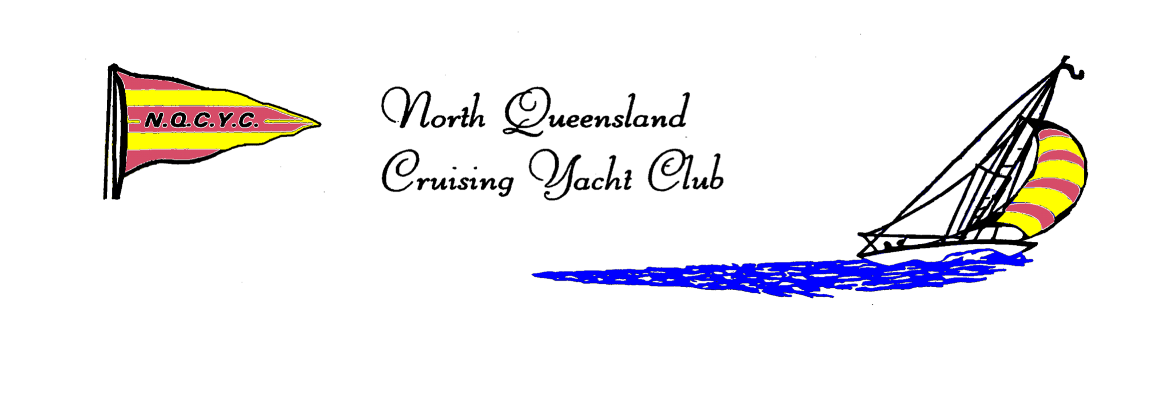
ABN : 82 700 909 965
Ph (07) 4786 3490
E : admin@nqcyc.com
www.nqcyc.com.au/
is hosting
Sail Bowen

5th and 6th November 2016
at the
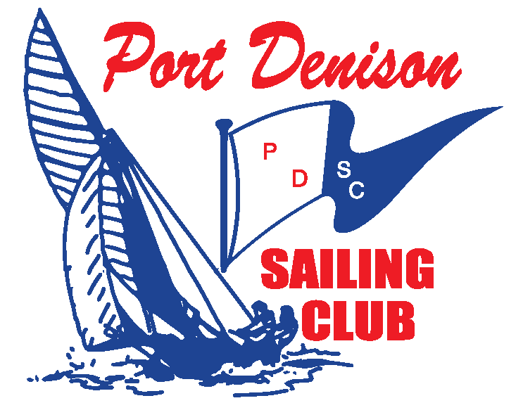
1 Thomas Street
Front Beach,
Bowen Q 4805

Off-Beach Regatta for all classes of
Dinghies & Catamarans
incorporating….

NQ Optimist Championships
NQ Arrow Championships
NQ Weta Championships
NQ Sabot Traveller’s Series

NOTICE OF RACE

Registrations details at www.nqcyc.com.au/

Contact : Adelaide Belyea
E : sailbowen2016@gmail.com
Ph : 0467557123

- Rules
The regatta will be governed by the rules as defined in the Racing Rules of Sailing and the Yachting Australia (YA) Special Regulations – Part 2 for off the beach boats.
- Advertising
2.1 Advertising will be restricted to Category A.
2.2 Boats may be required to display advertising chosen and supplied by the organising authority.
- Eligibility and Entry
3.1 The regatta is open to all classes of off the beach dinghies and catamarans.
3.2 Green/Intermediate Fleet is available using PDSC club Tackers and Sailcubes.
3.3 A minimum of 7 boats of the same class is required to constitute a Division.
3.4 All competitors shall be current members of a Yachting Australia affiliated Yacht/Sailing Club.
3.5. Registrations to sailbowen2016@gmail.com by 1600 on the 29th October 2016.
3.6. Late entries may be accepted up until 1000 on Saturday, 5th November 2016 and will incur a surcharge of $50.
- Fees
Required fees are as follows:
- Senior Sailors (each) $50
- Junior Sailors (each) - 16 and under $30
- Green/Intermediate Fleet Sailors (each) $30
- Late Entry Surcharge $50
- Schedule of Events
DAY/DATE | ACTIVITY | TIME
Saturday  5 November 2016 | Registration & Breakfast | 0800 – 1000
 | Competitors meeting | 1000
 | Racing ( 4 Races) | First Warning Signal 1100
 | Hot Food &Beverages | All day
Sunday  6 November 2016 | Breakfast | 0800 - 1000
 | Competitors meeting | 0900
 | Racing (4 Race) | First Warning Signal 1000
 | Hot Food & Beverages | All day
 | Presentation | ASAP after racing.

  - There will be a maximum of four races (back to back) per day.
  - A short lunch break will be provided on the water between races.
  - Sailors will be provided with an on-water lunch (sandwich and water) each day as part of registration.
  - No warning signals will be made after 1500 on Sunday, 6 November.

- Measurement
  - Measurement and crew weight shall be in accordance with the relevant class rules.
  - Boats may be inspected for safety equipment and measurement compliance at any time during the regatta.
  - Random measurement and compliance checks will be made throughout the regatta at the discretion of the race committee.
- Sailing Instructions
Printed copies of the Sailing Instructions will be available at registration.
The Sailing instructions will also be available at www.nqcyc.com.au/ 48 hours prior to the first race.
- Venue
Port Denison Sailing Club, Thomas Street Bowen and on the waters of Port Denison.
- Courses
The courses will be detailed in the Sailing Instructions.
- Penalty System
Appendix P will apply.
- Scoring
  - The Low Point System of Appendix A will apply, amended as follows :
  - Eight (8) races are scheduled of which three (3) races are required to be completed to constitute a series.
  - (a) When fewer than five (5) races have been completed, a boat’s series score will be the total of her race scores.
(b) When five (5) to seven (7) races have been completed, a boat’s series score will be the total of her race scores excluding her worst score.
(c) When eight races have been completed, a boat’s series score will be the total of her race scores excluding her two worst scores.
  - Handicap System.
- For Classes with 7 or more boats, boats will be scored in their finishing positions.
- For Classes with less than 7 boats, YV Yardsticks shall apply.
  - Prior to finishing, a boat may be given an allocated place score entirely at the discretion of the race committee. This changes rules A4 and A5.
- Support Boats
  - Team leaders, coaches and other support personnel shall stay at least 200 meters outside areas where boats are racing from the time of the preparatory signal for the first division to start until all the boats have finished or the race committee signals a postponement, general recall or abandonment. Support boats shall not signal to competitors by any means during the race.

- Rights to use Name and Likeness
By participation in this event, a competitor automatically grants to the Organising Authority and the sponsors of the event, the right in perpetuity, to make use and show from time to time and at their discretion, any motion pictures, still pictures and live, taped or film television and other reproductions of him/her during the period of the competition for said event in which the competitor participated and in all material related to the said event, without compensation.
- Prizes
  - Prizes will be given to 1st, 2nd and 3rd in each division.
  - Additional prizes may be given at the discretion of the organising authority.
- Disclaimer of Liability
All those taking part in this Regatta, do so at their own risk and responsibility. The Organising Authority and all others involved in the conduct and management of this event, shall not be liable for any loss of life or injury, or for the loss of property or damage thereto, whatsoever or howsoever occurring. The race documents and instructions in no way limit or reduce the complete and unlimited responsibilities of a competitor for the management and care of a boat that they have entered in the regatta. Attention is drawn to ISAF Fundamental rule 4.
- Insurance
Each participating boat shall be insured with valid Third-Party Liability Insurance with a minimum cover of AUD $5 million (recommended $10 million) per event.
Each boat competing will be required to produce proof of insurance consisting of the insurer’s name and the policy number of the boat’s insurance policy.
Sailors chartering boats from the NQCYC/PDSC or Whitsunday Sailing Club will not need to provide insurance details.
- Catering
Breakfast will be available on both mornings. On-water lunch (sandwich & water) will be provided for each sailor as part of registration, each day of racing. Lunch will be available from the canteen for spectators. Light snacks, soft drinks and a licensed bar will operate throughout the regatta. Hot food will be available to purchase on Saturday afternoon after racing. A sausage sizzle will be available for purchase on Sunday after racing before Regatta Presentation.
Discounted rate per room for Sail Bowen participants.

- Accommodation
Port Denison Motor Inn Bowen Tourism
Phone: [07] 47 866 822 Phone: 07 4791 2000
Email: http://www.portdenisonmotorinn.com.au/ Website: www.tourismbowen.com.au

- Further Information
Name : Gary Bruce Name : Kylie Gummow
Phone: 0439732931 Phone : 0427862346
Email: brusta@tpg.com.au Email : kylie.gummow@bigpond.com

THANK YOU TO THE REGATTA SPONSORS

Arabon Seafoods
Bowen Fisherman's Seafood
Bowen Framing, Art and Trophies
Bowen Independent
Centrepoint Jewellers
Hickmott’s Quality Eggs
Horseshoe Bay Resort
Queens Beach Hotel
Port Denison Motor Inn

And our Major Fleet Sponsors

Christine & Athol Kennedy
Grandview Hotel
Justin Daley Consulting
L J Hooker
Maritime Union of Australia
Scott Gummow Kitchens
Snell’s Electrical
Tyrecorner

