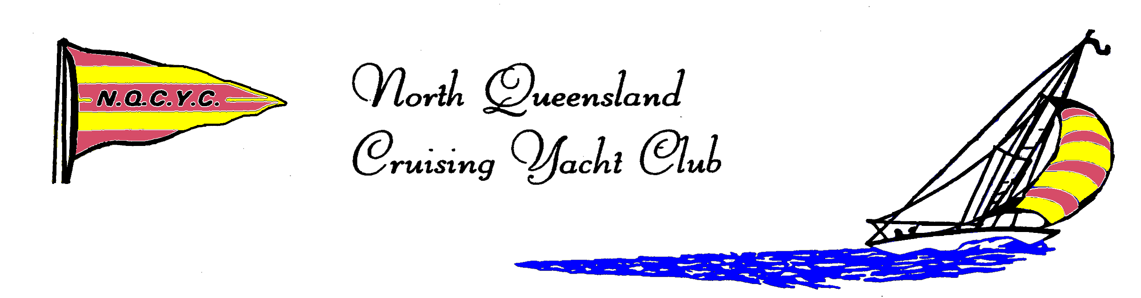
Sail Bowen
At the Port Denison Sailing Club
Off-Beach Regatta for all classes of Dinghies & Catamarans
Sail No. : ________________________________
Boat Name : _____________________________
Class : __________________________________
Boat Insurance Provider : __________________
Policy Number : __________________________
Home Club : _____________________________

5th and 6th November 2016
REGISTRATION FORM

SECTION 1 – Skipper’s Details
Skipper’s Name: _________________________ YA Number : _________________________
Date of Birth (____/____/____) Gender : Male Female Phone : __________________
Parents’ Name : _______________________________________________
Address: _____________________________________________________
Suburb: ______________________________________ Postcode: __________________
Phone : ________________________ Email : _____________________________________
Emergency Contact : Name : ___________________________ Number : ______________________

SECTION 2 – Crew’s Details
Crew’s Name: _________________________ YA Number : _________________________
Date of Birth (____/____/____) Gender : Male Female Phone : __________________
Parents’ Name : _______________________________________________
Address: _____________________________________________________
Suburb: ______________________________________ Postcode: __________________
Phone : _______________________ Email : ________________________________
Emergency Contact : Name : ___________________________ Number : ______________________
SECTION 3 – COMPETITOR’S AGREEMENT
I certify that all of the above information is correct, and I agree to be aware of , and be bound by, the ISAF Racing Rules of Sailing, the Notice of Race, the Class Rules as they apply, the Sailing Instructions and by all other rules governing this event.
I agree that it is a condition of entry that all competitors participate in this regatta entirely at their own risk (See also Rules of Sailing 4-Decision to Race).

I hereby declare that the above sailing dinghy carries legal liability insurance in the sum of at least AU $5,000,000 or the foreign currency equivalent.

By entering this event, I confirm that I accept these conditions and agree to indemnify North Queensland Cruising Yacht Club and Port Denison Sailing Club, their agents, servants and officials against any claim arising from this sailing dinghy’s participation in this event.
I attest that I am physically fit and have sufficiently trained for the rigours associated with this event.
I consent to receive any medical treatment that may be advisable in the event of an illness or injuries suffered by me during this event.
I give permission for the free use of my name, my voice or picture in any broadcast, telecast, advertising promotion or other account of this event.
Should the event be cancelled for any reason whatsoever, I understand that no liability of any kind will attach to any person, corporation or body involved or otherwise engaged in promoting or staging this event.
Safety precautions undertaken by the qualified sports officials (such as event briefings, setting of special rules and actions to administer the rules) are a service to me and the other competitors but are not a guarantee of safety.
I agree to abide by the conditions of the event as stated above, upon literature, and other material distributed in connection with the event and as directed by any volunteer of official involved with the event.

Signature of Skipper: ____________________________________ Date:________________________
Signature of responsible person for skipper under 18 years old:
Signature: ____________________________________________ Date: _______________________

Signature of Crew: ______________________________________ Date: _______________________
Signature of responsible person for crew under 18 years old:
Signature: ____________________________________________ Date: ________________________
SECTION 4 – NOMINATION
Junior Entry (16 and under) $30 All classes on outside course.

$30 Junior Entry – GREEN/INTERMEDIATE FLEET $30 Club Tackers /Sailcubes on inside course.

Senior Entry (over 16) $50 All classes on outside course.

Late fee after Saturday 29th October $50

All registrations include a packed lunch (sandwich and water) for on-water, for both days.
Vegetarian If you have any other dietary requirements please provide your own lunch.

SECTION 5 – PAYMENT
Cash Payment to Port Denison Sailing Club $___________

Direct Deposit $__________

Name: North Queensland Cruising Yacht Club
BSB: 014-504 Account Number: 9052-13043
Reference : SB (Sail Bowen) and sailor/s name Eg SB. Noah & Ruby Smith
Please send advice of payment by email to : sailbowen2016@gmail.com

Return this registration form via email to:
sailbowen2016@gmail.com before Saturday October 29th.
Contact Adelaide Belyea : 0467557123

